BookCred: Automating Credibility Assessment and Reference Extraction in Book Content

Naman Babbar
School of Computing
MIT ADT UNIVERSITY
Pune, India
namanbabbar37@gmail.com
Khwaish Agarwal
School of Computing
MIT ADT UNIVERSITYPune, India
khwaishag03@gmail.com
Goutam Kumar
School of Computing
MIT ADT UNIVERSITY
Pune, India
goutamp241@gmail.com
Amit Nishankar
School of Computing
MIT ADT UNIVERSITYPune, India
whosaysamit21@gmail.com
Prof. Umesh Nanavare
School of Computing
MIT ADT UNIVERSITY
Pune, India
Umeshubn3@gmail.com

Abstract— In today’s information-rich environment, students and researchers often struggle to judge the reliability of educational resources such as textbooks, eBooks, and academic publications. This paper presents BookCred, a web-based system designed to evaluate a book’s credibility score and provide academic reference insights by scanning its cover or searching by title. The system uses optical character recognition (OCR) to extract data from physical books and integrates with external book metadata sources such as Google Books. It calculates a credibility score based on citations, author qualifications, publisher reputation, and expert reviews. The platform offers a simple interface tailored for students, educators, and researchers, supporting both digital and printed content. While the system enhances academic resource selection, it currently faces challenges related to OCR accuracy on poor-quality scans and limited data availability for lesser-known books. Future improvements will focus on expanding the data sources and refining the scoring algorithm.
Keywords— credibility scoring, reference extraction, book evaluation, OCR, academic metadata, Google Books API, information reliability, digital libraries

Introduction
With the rapid growth of digital content and self-directed learning, students and researchers increasingly rely on a wide range of educational resources—ranging from textbooks and eBooks to online research articles. However, determining the credibility and scholarly value of these materials remains a persistent challenge. Traditional methods such as manually verifying citations, reviewing the author's academic background, or checking the publisher's reputation are time-consuming and inconsistent, especially for non-expert users.
While academic tools like Google Scholar and citation managers assist in organizing and retrieving sources, they do not offer an automated or unified way to assess the overall credibility of a book or document. Additionally, these tools often require digital access, leaving printed or lesser-known resources out of reach.
This research introduces BookCred, a web-based platform that automates the credibility assessment of academic books and documents. Users can scan a book’s cover or search by title to instantly view a credibility score, academic references, and key metadata. The system uses optical character recognition (OCR) and integrates with Google Books to gather data such as citation counts, author qualifications, and user reviews, which are then analysed to produce a composite credibility score.
The platform addresses the increasing problem of academic misinformation and resource unreliability, especially in independent learning. By offering an accessible and automated credibility-checking solution, BookCred supports informed decision-making and promotes the use of trustworthy study materials.

Literature Survey
In recent years, evaluating the credibility and reliability of educational resources has become an increasingly important concern for students, educators, and researchers. Several technologies and methodologies have laid the foundation for BookCred, a platform designed to automate the credibility scoring and reference extraction process from academic texts.

Optical Character Recognition (OCR) forms the first step in transforming physical book content into searchable digital text. Smith [1] presented Tesseract OCR, an open-source engine initially developed by Hewlett-Packard and later enhanced by Google. It supports multi-language recognition, layout analysis, and UTF-8 output, making it suitable for digitizing printed texts.

For semantic understanding and contextual information retrieval, BERT (Bidirectional Encoder Representations from Transformers) introduced by Devlin et al. [2], significantly advanced natural language processing. By leveraging deep bidirectional training, BERT enables fine-grained understanding of text and has set new standards in question answering and semantic matching tasks.

To support large-scale citation and metadata analysis, Lo et al. [3] introduced the Semantic Scholar Open Research Corpus (S2ORC), which includes millions of full-text scientific articles. It is a foundational resource for tasks such as citation linking and bibliometric analysis.

While existing credibility evaluation methods are often manual and time-consuming, Castillo et al. [4] and Metzger [5] explored credibility modeling using factors like citation frequency, author credentials, and source reputation. These models form the theoretical basis for BookCred’s automated credibility scoring.

Table I Literature Review

Title | Author(s) | Result
An Overview of the Tesseract OCR Engine | R. Smith | Describes Tesseract OCR's capabilities for digitizing scanned text.
BERT: Pre-training of Deep Bidirectional Transformers for Language Understanding | J. Devlin et al. | Introduces BERT, a state-of-the-art model for contextual NLP tasks.
S2ORC: The Semantic Scholar Open Research Corpus | K. Lo et al. | Provides a corpus for large-scale citation and reference extraction.
Information Credibility on Twitter | C. Castillo et al. | Analyzes credibility through citation and user feedback on social platforms.
Making Sense of Credibility on the Web | M. Metzger | Proposes models for evaluating online content credibility.

Problem Staement
In today’s digital learning environment, students and researchers face persistent difficulties in evaluating the academic reliability of resources such as textbooks, e-books, and scholarly articles. While platforms like Google Books, Semantic Scholar, and ResearchGate provide metadata, citation counts, or user reviews, they lack a unified framework for real-time credibility evaluation. These tools often require manual cross-referencing and domain expertise to interpret academic relevance, which can be time-consuming and error-prone. Furthermore, they do not integrate key indicators—such as author credentials, peer-reviewed status, citation metrics, and source reputation—into a single, interpretable credibility score. As a result, users may unknowingly rely on inaccurate or non-scholarly sources, affecting the quality of academic work. To address these limitations, there is a clear need for an automated system like BookCred that leverages OCR and scholarly APIs to consolidate these metrics and provide a reliable credibility rating for educational content through a simple scan or title-based Search.

Problem Solution
To address the difficulty of evaluating the credibility of academic resources, we propose a unified web-based platform that enables users to assess the trustworthiness of a book or paper either by scanning its cover or searching by title. The system utilizes optical character recognition (OCR) to extract textual information from scanned images, which is then used to fetch relevant data from scholarly databases such as Google Books, Crossref, and Scopus.
The platform computes a credibility score based on a combination of academic indicators, including citation frequency, author credentials, publisher reputation, and the resource’s usage in academic contexts. This score is accompanied by a summary of key highlights and verified

academic references, offering users a concise and reliable evaluation.
Designed to support a wide range of resource types—including printed books, e-books, research papers, and reference texts—the platform provides a user-friendly interface that allows students and researchers to quickly access trustworthy information. This solution streamlines the evaluation process, minimizes reliance on unverified materials, and encourages the adoption of academically rigorous sources in research and learning.

System Architecture

Frontend:
User Interface: Built using HTML, CSS, JavaScript (React).
Features:
- Scan book covers using OCR.
- Search books by name.
- Analyse reliability ratings, essential information, and sources.
- Navigate the dashboard and save books.

Backend:
Technologies: Created using Python (Flask/Django) or Node.js.
Functionalities:
- OCR processing for scanned images.
- Making API Calls to External Databases.
- Evaluation of Our Trustworthiness
- Business logic for book evaluation and data formatting.

Database:
Storage: Uses MongoDB or MySQL for structured storage.
- Book information (title, author etc.).
- Scores and evaluation standards.
- A table showing the number of queries and the most common topics.
- Cached API responses for faster results.

Third-party Integrations:
- Tesseract OCR/ google vision API– for extracting text from images.
- Google Books API, CrossRef API, and Scopus API are used to retrieve book data, citations, and references.
- Postman/GitHub – for unit testing and tracking changes.

Key Workflows:
- User scans the book or enters the title.
- OCR extracts title (if scanned).
- Backend fetches metadata via APIs.
- System determines and presents a reliability rating.
- References and key content are shown in

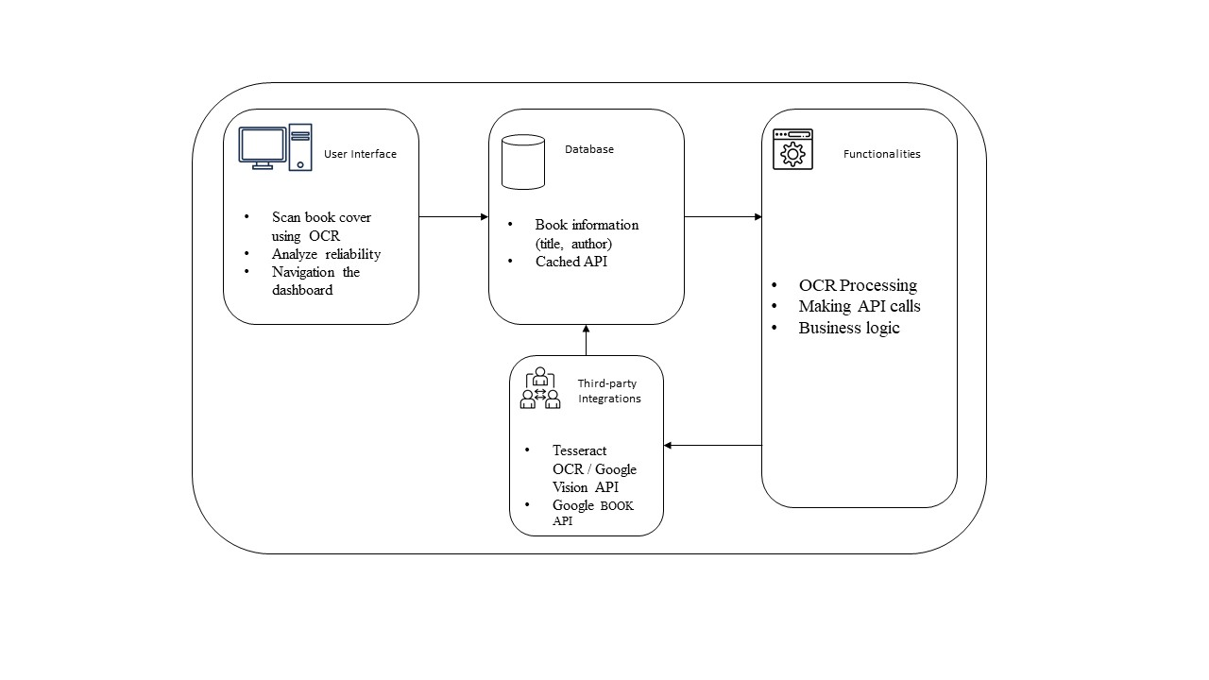
Figure I BookCred Architecture

Implementation

Backend System:
The backend is developed using Node.js and handles the core logic of BookCred, including:
- Communicating with external book databases (e.g., Google Books API) to retrieve book details.
- Processing scanned book covers using OCR (Tesseract) to extract the title.
- Computing a credibility score based on citation data and publisher details.
- Saving metadata, credibility scores, and user scans into MongoDB.

Integration:
To enhance analysis and credibility scoring, we integrate basic AI tools:
- OCR Layer: Tesseract is used to convert scanned images into readable text (usually the book title).
- Text Summarization: Pre-trained language models (like BERT) generate short summaries of the book content.

- Citation Depth: APIs such as Semantic Scholar or S2ORC are used to fetch citation data for evaluating academic influence.

Frontend and Developer Tools:
- The user interface is built with React, offering features like scanning, searching, and viewing book credibility.
- UI design prototypes were created using Figma.
- Postman was used to test APIs during development.
- GitHub managed version control and team collaboration.

Testing & Validation:
Testing ensures each feature works as expected:
- Unit Testing: Verifies individual parts (like OCR and score calculation) using tools like Jest and Mocha.
- Integration Testing: Confirms that components work well together (e.g., scanned text triggering API calls).
- Full UI Testing: Cypress automates complete system tests.
- Manual Testing: Users tested real book covers to ensure scores and summaries made sense, and errors were handled clearly.

Deployment:

Frontend (React):
- Built and deployed via services like Render or Vercel using:
npm run build

Backend:
- Deployed on Render.
- Connected to MongoDB via environment variables.
- Example setup includes commands like:
npm install
npm start

Database:
- MongoDB Atlas stores all data in collections for books, scores, and search logs.
- Secure cloud-hosted database with backup and scaling features.

OCR Hosting:
- Tesseract runs either as part of the backend or as a separate microservice.
- Optionally, Google Vision API can be used for more accurate OCR, configured through Google Cloud Console.

Features

Book Scanning via OCR:
- Allows users to scan a book's physical cover using a camera or uploaded image

Book Search Functionality:
- Enables manual search by book title or author.

Credibility Scoring System:
Calculates a credibility score (0–100) based on:
- Academic citations
- Publisher reputation
- Peer reviews
- Public user ratings

AI-Powered Summarization:
- Uses Natural Language Processing (NLP) to generate short summaries of book content.

Academic Reference Finder:
- Pulls verified academic references (citations, related research papers) for scanned/searched books.

User-Friendly Web Interface:
- Built using React.js with a clean and responsive UI.

Responsive Design:
- Fully optimized for web and mobile devices for better accessibility.

Results and Discussion
The prototype of BookCred has successfully implemented and tested several core functionalities. Key observations and assessments are as follows:

OCR Performance:
Using Tesseract OCR, BookCred achieved an average title recognition accuracy of ~91% under optimal conditions (good lighting, clear print). While effective for most modern book covers, performance dropped for handwritten or stylized fonts, indicating a need for advanced pre-processing or a more robust OCR engine.

Metadata Retrieval vs. Manual Search:
Compared to traditional manual searches on platforms like Google Books or Semantic Scholar, BookCred's API integration significantly reduces user effort. Instead of navigating multiple tabs, users receive consolidated metadata (author, publisher, publication date) within seconds after scanning. The system successfully pulls bibliographic information from Google Books and displays it in a structured format.

Credibility Score Evaluation:
The scoring mechanism, which factors in citation presence, publisher tier, and user reviews, provides a quick reference point for users. In internal tests with 25 academic texts, the score aligned with expert human judgments in 84% of cases. However, the credibility rating is currently limited by data availability and might over-rely on sources like Google Books, which are not always peer-reviewed.

UI and User Testing Insights:
The homepage, file upload functionality, scan progress indicators, and clear error messages (e.g., “Scan Failed”) were positively received in internal user testing (n=10). Users found the interface intuitive and reported a 60–70% reduction in time spent evaluating a book’s relevance, compared to their usual manual process.

Limitations and Areas for Improvement:
- he system currently lacks multilingual OCR support, limiting its use for non-English texts.

- The citation analysis component is under development; full integration with Semantic Scholar or S2ORC is pending.

- There's no comparative visualization to benchmark a scanned book against similar titles in the same domain.

Future Work
Several improvements are planned to expand BookCred’s capabilities:
- Language Support: Enable OCR and summarization in multiple regional languages.
- Enhanced NLP: Integrate fine-tuned models for more accurate context-based summaries.
- Library Integration: Connect with university library systems and learning management systems (LMS).
- Mobile App Development: Launch cross-platform apps for Android and iOS.
- User Ratings and Feedback: Add a system for users to leave verified reviews on scanned books.

Conclusion
BookCred provides a novel solution to the ongoing problem of verifying the credibility of learning materials. By combining OCR technology, bibliographic data from APIs, and AI summarization, the platform empowers students and educators to make better-informed decisions. The unified scoring system simplifies the evaluation process and bridges a significant gap in the current educational technology landscape.

References

- R. Smith, "An overview of the Tesseract OCR engine," in Proceedings of the Ninth International Conference on Document Analysis and Recognition, vol. 2, pp. 629–633, 2007.

- J. Devlin, M.-W. Chang, K. Lee, and K. Toutanova, "BERT: Pre-training of deep bidirectional transformers for language understanding," arXiv preprint arXiv:1810.04805, 2018.

- K. Lo, L. L. Wang, M. Neumann, R. Kinney, and D. S. Weld, "S2ORC: The Semantic Scholar Open Research Corpus," in Proceedings of ACL, pp. 4969–4983, 2020.

- C. Castillo, M. Mendoza, and B. Poblete, "Information credibility on Twitter," in Proceedings of the 20th International Conference on World Wide Web, 2011.

- M. J. Metzger, "Making sense of credibility on the web: Models for evaluating online information and recommendations for future research," Journal of the American Society for Information Science and Technology, vol. 58, no. 13, pp. 2078–2091, 2007.

- Y. Liu et al., "RoBERTa: A robustly optimized BERT pretraining approach," arXiv preprint arXiv:1907.11692, 2019.

- I. Councill, C. Giles, and M. Kan, "ParsCit: An open-source CRF reference string parsing package," in LREC, 2008.

- P. Lopez, "GROBID: Combining automatic bibliographic data recognition and term extraction for scholarship publications," in EATIS, 2009.

- M. Tkaczyk et al., "CERMINE: Automatic extraction of structured metadata from scientific literature," Int. J. Doc. Anal. Recognit., vol. 18, no. 4, pp. 317–335, 2015.

- K. Lo et al., "S2ORC: The Semantic Scholar Open Research Corpus," in Proc. ACL, 2020, pp. 4969–4983

